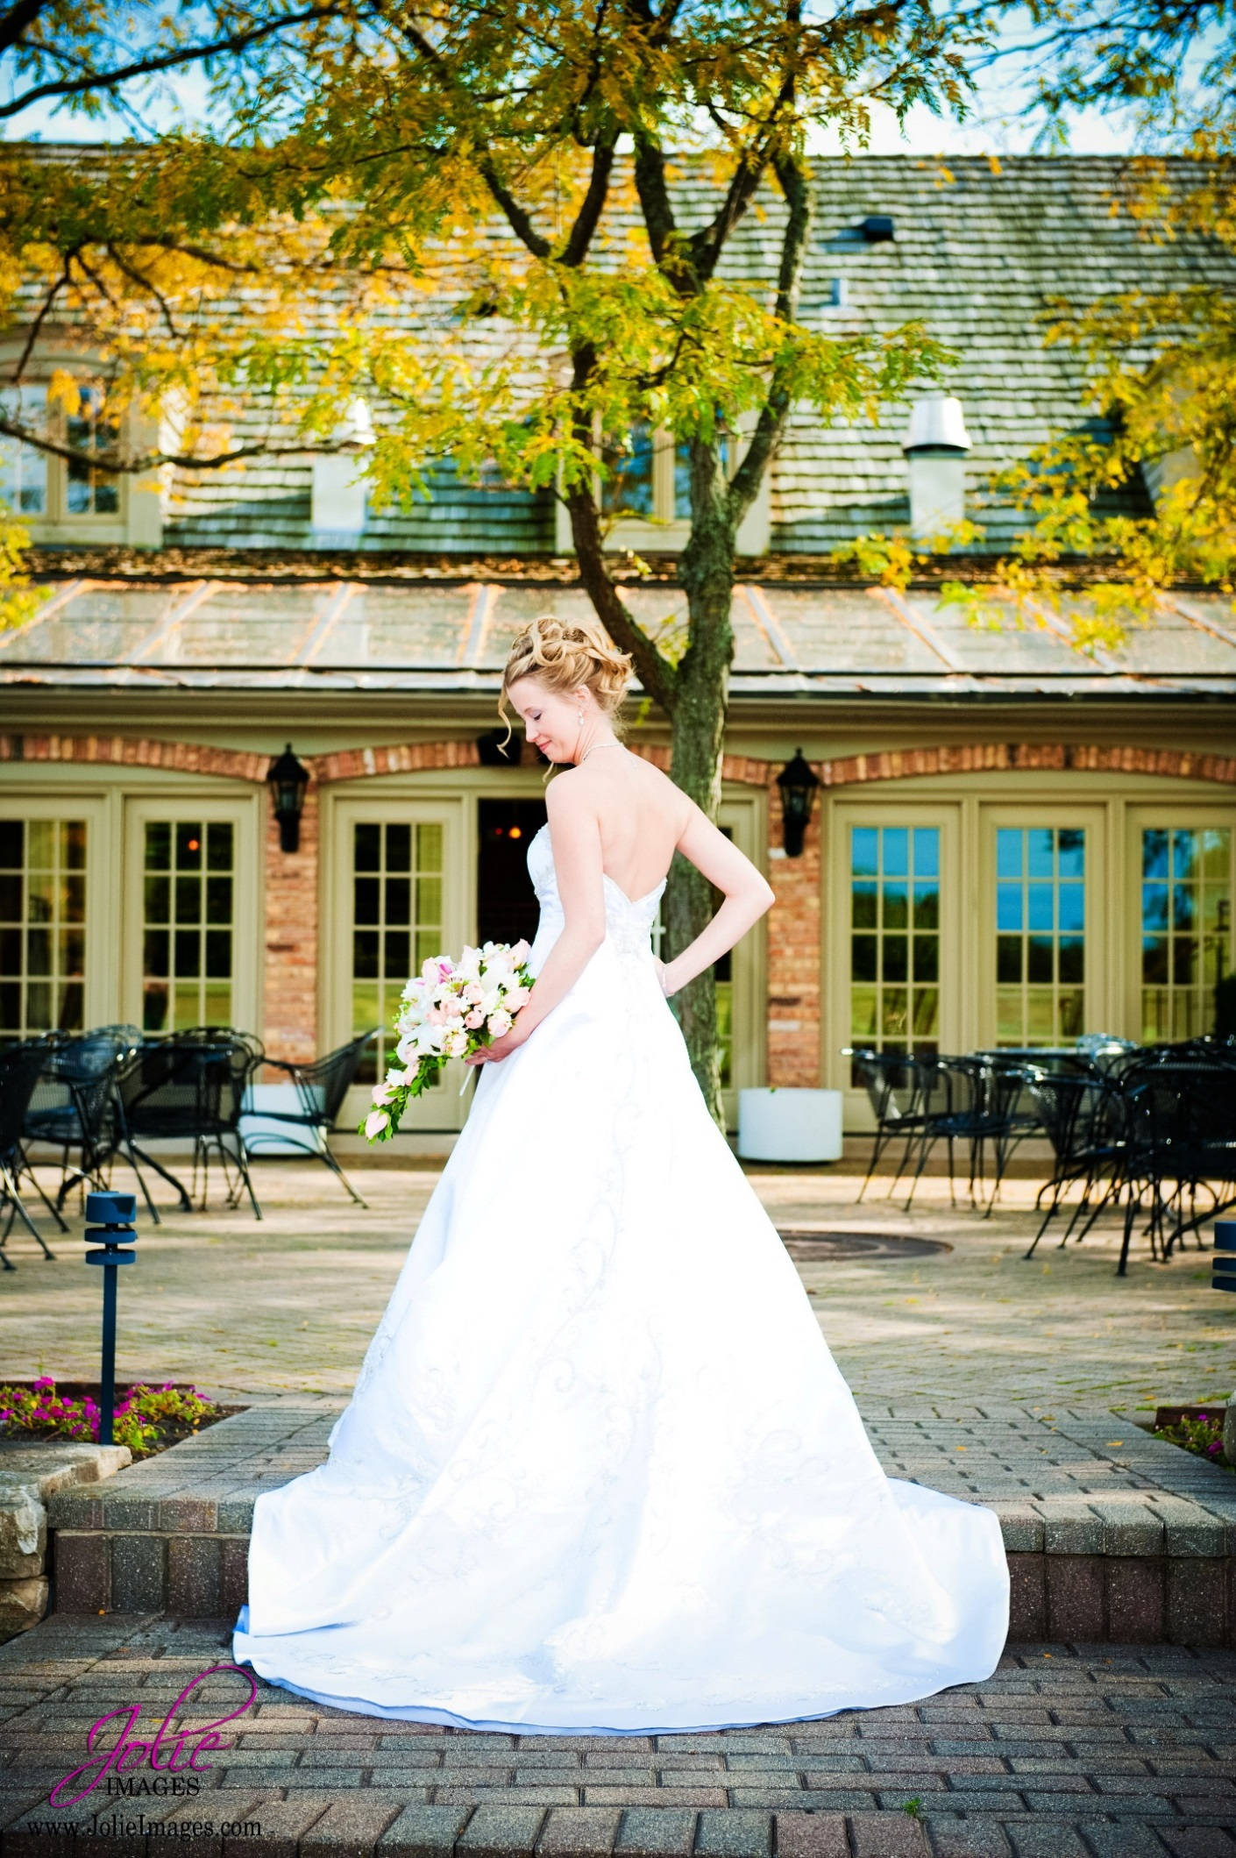

TURNBERRY GOLF CLUB WEDDING PACKAGE

Congratulations on your engagement. Our best wishes to you and your families as you plan your wedding day.
Turnberry Golf Club shares your vision in making this the perfect celebration, for you and your loved ones. Our staff is committed to servicing your wedding from start to finish.
Wedding Package Inclusions:
- Select Butler passed hors d’ oeuvre’s during cocktail hour.
- Four hours of open bar service with house liquors *upgraded premium liquors available for an additional cost.
- Plated dinner service
- Wine service during dinner
- Complimentary cutting and service of your wedding cake
- Floor Length Table Linens
- Chiavari Chairs
- White Linens and Napkins. Choice of Colored Napkins included.
- Specialty Colors will be an additional cost.
- Skirted tables for DJ, cake, gift, and place cards
- Complimentary tasting for two
- Rehearsal for Ceremony
- Complimentary foursome of golf
- Complimentary banquet room that can accommodate up to 200 guests.

CEREMONY
A beautiful outdoor space for your ceremony. Optional use of our garden room with an outdoor patio and views of our golf course for your cocktail hour

$800.00- Ceremony and Garden Room
$500.00- Ceremony only/ Garden Room Only

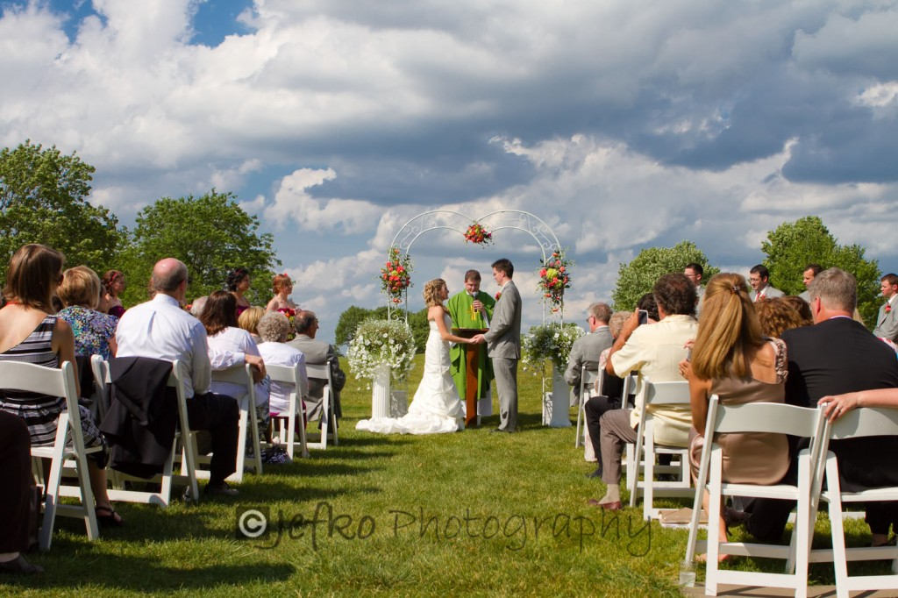

COCKTAIL HOUR
BUTLER PASSED HORS D’ OEURVES- (Choose Two)
HOT
- Bacon Asparagus
- Meatballs (choice of Italian, Pineapple or Swedish)
- Vegetable egg roll with sweet and sour sauce
- Mini Chicken Wellington
COLD
- Crab Rangoon
- Tomato Zucchini Bruschetta
- Caprese skewers
DISPLAYS (serves up to 40 guests)
- Vegetable tray- $95.00
- Fresh fruit - $110.00
- Domestic cheese and crackers- $100.00
- Imported cheese and crackers- $120.00

DINNER SERVICE
FIRST COURSE
- Garden Salad- mixed baby greens paired with cherry tomatoes, cucumbers, carrots, and garlic croutons served with balsamic dressing.
- Tossed Caesar Salad- romaine lettuce paired with cherry tomatoes, croutons and shaved parmesan cheese served with classic Caesar dressing.
- Mediterranean salad of red and green baby romaine lettuce, marinated cherry tomatoes, Kalamata olives, red onion, feta cheese, English cucumber, roasted garlic, and oregano vinaigrette.
- Served with gourmet rolls and butter.

MAIN COURSE
CHICKEN ENTRÉE’S- $75.00
- Grilled Chicken and Eggplant Parmesan Stacks with Homemade Pomodoro Marinara and Fresh Mozzarella finished with a drizzle of Basil Pistou and Shaved Pranna Grada
- Seared Chicken Breast with Roasted Portabella Mushrooms and Caramelized Onions in a light Sherry Cream Sauce
- Grilled Chicken with Lemon and Roasted Garlic moistened with a Citrus Chardonnay Sauce and a lace of Arugula Pesto

SEAFOOD ENTRÉE’s - $90.00
- Seared Atlantic Salmon with Mushrooms and Onions in a Light Roasted Garlic Sauce
- Italian Parsley and basil rubbed Atlantic Salmon
- Pan Seared Chilean Sea Bass with Citrus Salsa

BEEF ENTRÉE’S- $85.00
- Roasted Prime Rib 12oz Served with Cabernet Sauce or Au Jus
- Pepper crusted seared tenderloin served with fresh grated horse radish cream and a roasted cremini Merlot reduction.
- Filet Mignon 8oz with Mushrooms and Onions with a Cabernet Sauce

SURF & TURF-MARKET PRICE
- Grilled 6oz Filet Mignon with Merlot Sauce and a seasoned chicken breast
- Grilled 6oz Filet Mignon with Cabernet Sauce and Shrimp

VEGETARIAN ENTRÉE’S- $75.00
- Stuffed Shells filled with Wilted Arugula, Imported Ricotta and Roast Cremini Mushroom baked in a Roasted Red Pepper Sauce and finished with a lace of Asiago Alfredo
- Pave Stacks of Roasted Vegetable and Imported Goat Cheese finished with a Roasted Tomato Sage Coulis finished with a drizzle of Parsley Almond Pistou

CHILDREN’S ENTRÉE-$15.00
12 and Under
- Chicken Fingers with French Fries

ACCOMPANIMENTS
(Select one starch and one vegetable)
STARCHES
- Whipped Potatoes
- Roasted Potato Spears
- Wild Rice Blend

VEGETABLE
- Green Beans and Carrots
- Broccoli
- Seasonal Vegetable Medley

Dietary and Gluten Free Meals are available upon request
DESSERT
Sweet Table with Coffee Station $9.95/PP
Chefs Assortment of Sweets


BAR PACKAGES (Four hours included)
HOUSE LIQUORS
Barton’s Vodka, Barton’s Rum, Barton’s Gin, Juarez Gold Tequila, DE Kuyper Amaretto, Seagram’s VO, Dewars White Label, Southern Comfort, Christian Brother Brandy,
DOMESTIC BEERS-
Budweiser, Bud Light, Coors Light,
Miller Lite on Draft
BAR UPGRADES- $13.00 PER PERSON for guests over 21
PREMIUM LIQOURS
Tito’s Vodka, Kettle One, Grey Goose, Tanqueray Gin, Beefeaters, Bacardi, Captain Morgan, Cuervo Tequila, Jack Daniels, Jim Beam, Seagram’s VO, Canadian Club, Crown Royal, Jameson, Glenfiddich, Johnny Walker Red, Johnny Walker Black, Baileys, Kahlua,

Premium Beers
Michelob Ultra, Stella, Miller Light, Corona, Corona Light, Crystal Lake Brewery, Beach Blonde, Fox Rocker, Blue Moon, Leinenkugel Seasonal, IPA, Revolution Anti-Hero, Slalom King
CHAMPAGNE TOAST-$3.50/PP

TURNBERRY GOLF CLUB EVENT POLICIES
- All food & beverage must be provided by Turnberry Golf Club and are subject to a 20% service charge and current state sales tax 8%. These prices are based on the current market value. Please be aware that prices are subject to change should the market value increase.

- To go containers are not permitted to be taken from event.

- No outside alcohol is allowed to be brought in to Turnberry Golf Club.

- A minimum guaranteed attendance is due 14 days prior to event for all meal functions and is not subject to reductions. Charges will be based on this guarantee, or on actual attendance, whichever is higher.

- If no final guarantee is received, the original estimated attendance would be used and charged accordingly.

- A maximum of two entrée choices may be selected for dinner. A minimum of 45 people for split entrees. Receptions with split entrée’s must give exact quantities of each in their final counts and supply a place card for each guest clearly indicating their entrée selection.

- All guest 21 must present an ID to consume alcohol. Shots are not permitted.
Only one alcoholic beverage will be served at a time to a guest for personal consumption. Turnberry Golf Club reserves the right to limit and/or stop alcohol consumption to any guest when deemed necessary.

- Food and Beverage Minimum is Required: If the room revenue is not met a room rental fee will be applied.
- Friday-$10,000.00
- Saturday-$12,000.00
- Sunday-$8000.00

- A $1000.00 non- refundable deposit is required to secure the date and will be applied to the final balance. $1000.00 will be due 3 Months after signing contract. 50% of balance will be due 6 months prior to the reception date. Final Balance will be due 14 days prior to the reception date.

